 Translated from Russian to English - www.onlinedoctranslator.com

COURSE WORK

By: | PM.01 Participation in the design of network infrastructure
interdisciplinary course: |  |  | MDK 01.02. Organization, principles of construction and operation of computer networks
on the topic:
Designing a Network with Dedicated Wi-Fi Zones for Employees and Guests

Completed by student: |  | Terada Kun

EXERCISE
to the student's coursework
on the topic:Designing a network with dedicated Wi-Fi zones for employees and guests»
Objective of the work: | Develop a network withdedicated Wi-Fi zones for employees and guests
The main issues to be addressed are:
1.Designing a VLAN architecture to isolate employee and visitor traffic.
2.Configure inter-VLAN routing, ACLs, and VLAN binding to ports and SSIDs.
Theoretical part:
1. Basics of Ethernet technology and principles of network construction
2. Virtual Local Area Networks (VLANs) and Trunking Technologies
3. Spanning Tree Protocol (STP) and its evolution
4. Principles of building fault-tolerant networks and monitoring
Practical part:
1. Building and Basic Network Configuration in Cisco Packet Tracer
2. Implementation
Main literature:
1. Cisco LAN Switching Configuration Handbook
2. Switching, Routing, and Wireless Essentials Companion Guide

TABLE OF CONTENTS
INTRODUCTION 5
CHAPTER 1. TECHNICAL AND THEORETICAL JUSTIFICATION OF THE PROJECT 8
1.1 Analysis of wireless network standards and technologies 8
1.2 Computer network 8
1.3 Wired Networks 11
1.4. Wireless Networks 12
1.5 Wireless Personal Area Networks (WPAN) 12
1.6 Wireless Local Area Networks (WLAN) - Wi-Fi 13
1.7 Wireless Wide Area Networks (WWAN) 15
1.8 Future Network Security: Wired vs. Wireless Networks 15
1.9 Comparative analysis of WLAN architectures 16
1.10 Methods for WLAN Coverage Planning and Performance Calculation 17
1.11 Coverage planning methods 18
1.12 Gathering requirements and surveying the site 19
1.13 Selection of technologies and signal propagation models 19
1.14 Design and calculation using specialized software: 20
1.15. Project verification: 20
1.16 Types of Heat Maps for Analysis 21
1.17 Key design parameters: 22
1.18 Classification of potential risks: 23
1.19 Seamless Roaming: 23
CHAPTER 2. DEVELOPMENT OF AN ORGANIZATION'S COMPUTER NETWORK IN A VIRTUAL ENVIRONMENT 25
2.1 Cisco Packet Tracer 25
2.2 Requirements Analysis and Coverage Area Design 25
2.3 Setting up the main Wi-Fi router 27
2.4 Setting up Laptops for Employees in COOP 29
CONCLUSION 31
BIBLIOGRAPHY 33

INTRODUCTION
In today's business environment, wireless technologies have become a critical component of corporate infrastructure. The widespread use of mobile devices—laptops, smartphones, and tablets—for work requires stable and secure access to information resources from anywhere in the office. At the same time, providing high-quality internet access to guests and visitors has evolved from an optional extra to an element of corporate culture and a de facto standard for companies seeking to maintain their image.
However, simply deploying an open Wi-Fi hotspot creates a fundamental contradiction between the demand for convenience and the need to ensure information security. Consolidating employee and guest traffic on a single network poses serious risks: from unauthorized access to confidential corporate information to the vulnerability of internal systems to cyberattacks originating from the guest segment. Therefore, the pressing challenge is to design not just a wireless network, but an intelligent infrastructure capable of effectively separating and controlling network flows at a logical level, ensuring both unimpeded access to services and reliable data protection.
Research problemThe problem is the lack of a comprehensive approach to designing corporate Wi-Fi networks that would simultaneously address the challenges of ensuring high availability, wide coverage, load management, and, most importantly, strict traffic segmentation based on a role-based access model.
Main relevanceThe problems are caused by a paradigm shift in the role of the corporate wireless network: from an auxiliary service, it has transformed into a critical IT infrastructure, the failure or vulnerability of which directly impacts business processes and the company's security.
This is confirmed by the following key factors:
- The widespread use of mobile devices and the BYOD (Bring Your Own Device) concept:Employees use smartphones, tablets, and laptops for work, requiring seamless and secure access to corporate resources from anywhere in the office;
- The growth of IoT devices and smart systems:Sensors, access control systems, video surveillance, and smart office equipment all connect via Wi-Fi, creating additional overhead and new attack vectors, requiring isolation from the main network;
- Tightening information security requirements and regulatory framework:Laws and standards (such as Federal Law 152, GDPR, PCI DSS) impose strict requirements for the protection of personal and payment data, making network segmentation not just a best practice, but a mandatory requirement;
- Economic impact of downtime and data breaches:Network downtime leads to service interruptions, and data leaks due to insufficient segmentation lead to direct financial losses and reputational risks.
The purpose of this course workThe project is to develop a secure and efficient wireless network with dedicated Wi-Fi zones for employees and guests using a hypothetical company as an example.
To achieve this goal, the following tasks must be solved:
- Study the theoretical foundations and modern technologies for building wireless networks, including Wi-Fi standards, network security principles, and segmentation methods;
- To analyze the features of interaction of network devices in the controller architecture;
- Develop a logical and physical network structure for the selected facility, including coverage area planning and access point placement;
- Design a security system that provides various authentication mechanisms for employees and guests, as well as isolation
network segments in the virtual environment of the Cisco packet tracer application;
- Select network equipment and software that meets project requirements;
- Conduct tests and provide recommendations for operation.
The object of the studyThe process of designing a corporate wireless network is in progress.
Subject of the studyare methods and means for constructing segmented Wi-Fi networks using VLAN, RADIUS and controller architecture technologies.
Research methodsThe methods used in the work include: analysis of scientific literature and technical documentation, a systems approach to designing network infrastructure, a comparative analysis of network equipment and security methods, and a project modeling method.
Practical significanceThe key to the project is that the developed design can be used as a standard solution for small and medium-sized businesses requiring the implementation of a modern, secure, and scalable wireless infrastructure. All proposed solutions are based on publicly available and certified equipment, enabling practical implementation.
The structure of the work consists of an introduction, two chapters, a conclusion, a list of references, and appendices. The introduction explains the relevance of the work and sets out the goals and objectives. The first chapter examines the theoretical aspects of Wi-Fi network design. The second chapter presents practical network design for a company.

CHAPTER 1. TECHNICAL AND THEORETICAL JUSTIFICATION OF THE PROJECT

1.1 Analysis of wireless network standards and technologies
Wi-Fi originated with the introduction of the 802.11 standard in 1997. This standard became the foundation for wireless networks, allowing devices to connect to the internet wirelessly. Initially, Wi-Fi data transfer speeds were limited to 2 Mbps. Over time, newer versions of the standard were developed and implemented, significantly increasing speeds and improving connection quality.
Evolution of Wi-Fi from 802.11 (1997, 2 Mbit/s) to Wi-Fi 6/6E (802.11ax):
- 802.11b/g/n- 2.4 GHz, up to 150 Mbit/s;
- 802.11ac- 5 GHz, MU-MIMO, gigabit speeds;
- Wi-Fi 6- OFDMA, BSS Coloring, target efficiency in dense environments;
- Wi-Fi 6E- addition of 6 GHz range;
Key technologies:
- MU-MIMO - simultaneous transmission to multiple clients;
- OFDMA - efficient division multiplexing;
- Beamforming - directional beam formation;
- WPA3 - modern security;
Modern standards are focused on dense scenarios with multiple IoT devices and high throughput requirements.

1.2 Computer network
Computer network— is a set of two or more computing devices (computers, servers, printers, telephones, etc.) connected by communication channels for data exchange and resource sharing.
The main goals of creating networks:
- Sharing resources:files, printers, Internet channel;
- Data exchange:email, instant messaging, video conferencing;
- Increased reliability:data duplication and load balancing;
- Centralized management:software deployment, updates, account administration.
Computer networks are classified according to several criteria. One of the key ones is their territorial scale.
Types of computer networks by scale
1. PAN (Personal Area Network)
- Scale:Several meters (up to 10 m).
- Description:It is created to connect devices belonging to one person or located in his immediate vicinity.
- Technologies:Bluetooth, Zigbee, Infrared (IrDA), Wi-Fi Direct.
Examples:
- Connect wireless headphones, mouse or keyboard to your smartphone or PC.
- Transfer files between your phone and laptop via Bluetooth.
- Synchronizing a smartwatch with a smartphone.
2. LAN (Local Area Network)
- Scale:One or more buildings (house, office, school, hospital, airport).
- Description:Unites devices in a limited geographic area to share resources (Internet, printers, files).
- Technologies:Ethernet (wired), Wi-Fi (wireless).
Examples:
- A home network where a computer, laptop, TV, and smart speaker are connected to a single router.
- A corporate network in an office where all employee computers have access to shared servers and printers.
- Network on a university campus.
3. CAN (Campus Area Network)
- Scale:A group of buildings within one area (university campus, business park, large factory).
- Description:Essentially, it's a collection of several LANs interconnected. It occupies a position between a LAN and a MAN.
- Technologies:Ethernet, Wi-Fi, fiber optic connections.
Examples:
A university campus network linking the networks of different faculties, residence halls and libraries.
Network of a large industrial enterprise.
4. MAN (Metropolitan Area Network)
Scale:An entire city or a large area of ​​a metropolis.
Description:Connects multiple LANs within a city. Often used by providers to provide services.
Technologies:ATM, Frame Relay, DWDM, 5G as a backbone.
Examples:
- Cable television network (CATV).
- Network of city services (video surveillance, traffic light control).
- High-speed fiber-optic networks connecting the company's offices in different parts of the city.
5.WAN (Wide Area Network)
Scale:Country, continent, the whole world.
Description:Connects smaller-scale networks (LAN, MAN) located over a large geographical distance.
Technologies:IP/MPLS, satellite channels, submarine fiber optic cables.
Examples:
Internet— the largest WAN in the world.
A corporate network of an international company connecting branches in different countries.
The federal bank's network connecting all its branches.
Another fundamental classification feature is the data transmission medium.

1.3 Wired Networks
Wired networks use physical cables to transmit data.
Advantages:
- High speed and throughput:modern standards (for example, Ethernet up to 100 Gbit/s);
- Reliability and stability:the connection is less susceptible to external interference;
- Safety:a physical connection is required to access the network;
- Predictable delay:low and stable ping, which is critical for VoIP and online games;
Flaws:
- Lack of mobility:the device is tied to a socket;
- High cost of installation:requires installation of cable infrastructure;
- Scalability Difficulty:adding a new device often requires running new cable;
Main types of cables:
- Twisted Pair:The most common type for LANs. Available in unshielded (UTP) and shielded (STP). Uses an RJ-45 connector;
- Coaxial cable:Historically used in LAN, now more often for cable TV and Internet (DOCSIS);
- Fiber Optic Cable:Transmits data using light pulses. Provides tremendous speeds and transmission range. Used for trunk lines and connections between buildings.
Wired networks remain an essential component of modern infrastructures due to their reliability, security, and high data transfer rates. The choice of cable type depends on the specific requirements and operating conditions of the network.

1.4. Wireless Networks
Wireless Networks
Advantages:
Mobility:Freedom of movement within the coverage area.
Simplicity:Easy deployment without cables.
Scalability:It's easy to add a new device.
Flaws:
Interference:Walls and electronics degrade the signal.
Safety:Risk of radio signal interception.
Instability:Signal flickering and connection interruptions are possible.

1.5Wireless Personal Area Networks (WPAN)
WPAN (Wireless Personal Area Network)— is a wireless network for connecting devices in close proximity to a person (usually within a radius of up to 10 meters).
Key Features:
- Purpose:Connecting personal devices to share data;
- Range:Low coverage (from centimeters to 10-20 m);
- Power and energy consumption:Low, which allows devices to operate on battery power for a long time;
- Application:Create point-to-point or point-to-multipoint links for peripheral devices.
Key technologies and examples:
- Bluetooth:The most common standard;
- Examples:Wireless headphones, mice, keyboards, headsets, file transfer between phone and PC;
- Zigbee:Creating more complex mesh networks with low power consumption;
- Examples:Smart home (motion sensors, smart bulbs, security systems);
- Infrared port (IrDA):An outdated technology that requires line of sight.
Examples:Remote controls, old phones and laptops.
Comparison with other networks:
WPAN(personal space) vs WLAN / Wi-Fi (home/office) vs WMAN / WiMAX (city) vs WWAN / mobile network (global coverage).

1.6 Wireless Local Area Networks (WLAN) - Wi-Fi
Purpose:Wireless access to the network and Internet in the building/territory.
Main standards:
- Wi-Fi 4 (802.11n):Speed ​​up to 600 Mbps.
- Wi-Fi 5 (802.11ac):Speed ​​up to several Gbit/s.
- Wi-Fi 6 (802.11ax):Modern standard, higher efficiency and speed.
Components:Access point, router, wireless adapter.
Wi-Fi is widely used in offices, homes, educational institutions, and public spaces. To create a reliable and stable network, it is recommended to use multiple access points to provide coverage across the entire required area.

1.7 Wireless Wide Area Networks (WWAN)

Purpose:Citywide broadband access.
Technology:WiMAX.
Technology:Cellular networks (GSM, 3G UMTS, 4G LTE, 5G NR).
Purpose:Providing mobile communications and internet access through cellular operators.
Application:Modems and routers for internet access "in the field," mobile internet on smartphones and tablets.

1.8Security of the future networkWired vs. Wireless Networks
Here we lay the foundation for future network security by explaining how to separate and protect traffic.
- The need for segmentation in the corporate environment:
- Isolation of critical systems and data.
- Separate employee and guest traffic for security and management.
Compliance with security policies and regulatory requirements.
Segmentation technologies:
- VLAN (Virtual Local Area Network): The main tool. Operating principle, VLAN ID assignment. Creation of separate VLANs for: employees, guests, security services, IP telephony;
- SSID (Service Set Identifier): How different VLANs are assigned to different Wi-Fi network names (e.g. Company_Secure, Company_Guest).
Security mechanisms:
Authentication:
- WPA2/WPA3-Enterprise: Mandatory for employees. Integration with a RADIUS server and an account database (e.g., Active Directory). Each user has unique credentials;
- WPA2/WPA3-Personal (Pre-Shared Key): Why it is not suitable for employees, but can be used for some IoT devices;
- Guest Portal (Captive Portal): Authentication mechanism for guests (code entry, SMS, agreement with the rules).
Encryption: Uses AES. Benefits of WPA3 (protection against handshake attacks).
- Hiding SSID, MAC Address Filtering: Why These Methods Are Not Reliable Security (Also Needs to Be Mentioned).
Encryption using the AES standard and modern WPA3 protocols provides reliable data protection from interception and attacks. It's important to note that methods such as SSID hiding and MAC address filtering cannot guarantee complete security and should be used in conjunction with more comprehensive solutions.

1.9 Comparative analysis of WLAN architectures
Standalone ("fat" access points):
Principle: Each access point is configured independently.
Pros: Low cost for small networks (1-5 AP).
Cons: Complexity of management and making changes, lack of a unified security policy, complex roaming.
Applicability: Not suitable for corporate network with multiple access points.
Centralized (Controller-based architecture):
Principle: "Thin" access points (Lightweight AP) are managed by a central controller (WLC).
Pros: Centralized management, unified security policies, simplified roaming, scalability.
Disadvantages: Cost of the controller, presence of a single point of failure (although this is mitigated by clustering).
Applicability: Classic architecture for medium and large enterprises.
3.Cloud-managed:
Principle: Access points are managed via the manufacturer's cloud platform.
Pros: Easy to deploy and manage, remote access, subscription "as a service" (not CAPEX, but OPEX), automatic updates.
Cons: Ongoing operating costs (subscription), dependence on internet connection and cloud provider.
Applicability: A modern trend, ideal for distributed branches, popular with many vendors (Cisco Meraki, Aruba Instant On, Ubiquiti UniFi).
Comparison table: At the end of the paragraph, it is recommended to provide a table with the criteria (Cost, Scalability, Management Complexity, Reliability) and the assessment of each architecture.
Justification for the choice for the project: Based on the analysis performed, it is necessary to make a preliminary conclusion about which architecture is most suitable for the network being designed (e.g., "For this project, a cloud architecture was chosen due to its ease of management and low initial costs" or "Due to security requirements and integration with the existing infrastructure, a centralized controller-based architecture was chosen").

1.10 Methods for WLAN Coverage Planning and Performance Calculation
Designing a wireless local area network (WLAN) is a complex engineering process that extends far beyond simply installing access points. Quality design is essential for creating a network that will not only provide stable signal coverage in all required areas but also have sufficient performance to support multiple simultaneous users and modern applications. Coverage planning and performance calculation methods provide a systematic approach to solving these problems, allowing one to move beyond abstract theory about radio waves and Wi-Fi standards to the creation of a concrete, functional, and efficient network design.

1.11 Coverage planning methods
The main goal of planning is to predict the behavior of the radio signal in a specific environment before installation work begins and, based on this prediction:
- Provide continuous coverage (Roaming):The user should be able to move freely throughout the service area (office, warehouse, hotel) without losing connection. Their device should automatically and seamlessly reconnect from one access point to another.
- Guarantee the required quality of service (QoS):The signal must not only be "available" but also have sufficient power and signal-to-noise ratio (SNR) to support high-speed connections. This is critical for VoIP, video conferencing, and streaming video.
- Optimize network performance and capacity:The key objective is not simply to flood the area with signal, but to do so in a way that minimizes interference between neighboring access points operating on the same channels (minimizing co-channel interference). The network must be designed to handle the peak number of simultaneous users.
- Reduce capital and operating expenses (CAPEX/OPEX): Proper calculations allow you to determine the exact number of access points required and their optimal placement, avoiding both coverage gaps and equipment over-deployment.
Effective coverage planning enables the creation of a reliable and high-performance wireless network that meets user needs and ensures the stable operation of all services.

1.12 Gathering requirements and surveying the site
Definition of coverage areas:Identification of all rooms, open areas, and even adjacent territories (streets, patios) where Wi-Fi access is required.
User Density Analysis:Estimation of the number of simultaneous users in each zone (for example, a meeting room for 10 people, an open space for 100, an atrium for 500).
Determining traffic types and bandwidth requirements:Whether it's just web surfing and email, or resource-intensive applications like video streaming, large file transfers, and cloud services.
Physical inspection of the object (Site Survey):Study of the layout, building materials (concrete walls, glass partitions, metal structures significantly weaken the signal), the location of interference sources (radars, microwave ovens) and the existing cable infrastructure.

1.13 Selection of technologies and signal propagation models
Selection of Wi-Fi standards (802.11ac/ax):Determine which bands (2.4 GHz, 5 GHz, 6 GHz) will be used.
Using attenuation models:Mathematical models (such as the Log-Normal Attenuation Model) are used to predict signal strength at different points. These models take into account the distance from the access point and the type of environment (open space, office, industrial facility).

1.14 Design and calculation using specialized software:
Modern design is almost impossible without the use of specialized Wi-Fi modeling software (e.g. Ekahau Site Survey, TamoGraph NetSurvey, AirMagnet Planner).
Creation of a digital model of an object:Loading floor plans into software;
- Coverage area calculation (Modeling):Access points of the selected models are virtually "placed" on the plans. The program, using embedded propagation models and wall material data, calculates the predicted signal strength (RSSI) and signal-to-noise ratio (SNR) at each point on the plan. The results are visualized as heat maps.
- Channel Planning:The software automatically assigns access points to channels with minimal overlap, creating a reusable template (Channel Plan).
- Capacity Planning: Based on user density and traffic types, the system models expected network throughput and latency, helping determine whether there are enough access points to provide the required quality of service.
Using specialized software for designing and calculating Wi-Fi networks allows you to significantly reduce the time and costs of deploying and optimizing wireless networks, as well as increase their reliability and performance.

1.15. Project verification:
After the network is deployed, an active survey is conducted. A specialist with a laptop and a Wi-Fi adapter walks through all planned zones, collecting data on signal strength, speed, latency, and roaming success. This real-world data is compared with the design models. If discrepancies are detected, necessary adjustments are made, such as relocating access points or adding new equipment.

1.16 Types of Heat Maps for Analysis
Various types of heat maps are used to visually assess the quality of the designed network:
- RSSI Heat Map:Shows predicted or measured signal strength. This is the baseline for coverage assessment.
- SNR (Signal-to-Noise Ratio) heatmap:Shows the ratio of the useful signal level to the noise level. This is a more important parameter for assessing connection quality and potential speed.
- Data Rate Heat Map:Shows what data transfer speeds can be expected in different parts of the coverage area.
- Interference Heat Map:Visualizes areas where there may be interference from neighboring networks or incorrect channel settings.
Planning goals and objectives:
- Ensuring uninterrupted signal coverage in all target areas;
- Elimination of "dead zones";
- Optimized for high-density environments (many simultaneous connections).
Basic methods and tools:
Pre-deployment Survey:
- Analysis of layout, wall materials and potential sources of interference.
Predictive Modeling
- Using specialized software (e.g. Ekahau Site Survey, Ubiquiti Design Center) to predict coverage areas and access point placement based on the floor plan.
Active/Passive Survey:
- Measurements of actual signal parameters using temporarily placed access points.
Effective use of heat maps and planning tools enables the creation of a reliable and high-speed wireless network that meets user needs.

1.17 Key design parameters:
To ensure high-quality Wi-Fi coverage, it's important to consider the building's architecture to minimize signal obstructions, such as walls and furniture. It's important to properly zone the space, focusing on key areas such as work areas, meeting rooms, and breakout areas, and determine the optimal number of access points for each. Using directional technologies such as directional antennas and MU-MIMO improves spectrum efficiency and increases throughput in high-density areas.
Radio spectrum management involves planning communication channels to minimize interference and ensure a stable connection. Regular monitoring of the radio spectrum allows you to identify and eliminate sources of interference, such as neighboring Wi-Fi networks, Bluetooth devices, and microwave ovens. Configuring security settings, including modern encryption and authentication methods, protects the network from unauthorized access and attacks.
Network support and maintenance include regular firmware and driver updates to fix vulnerabilities and improve performance. Performance monitoring and problem diagnostics help promptly identify and resolve issues. Training staff and users on the proper use of network resources and compliance with security regulations is also important for maintaining a reliable and secure network.

1.18 Classification of potential risks:
Security risks such as unauthorized access, data interception, and DoS attacks can be minimized by configuring Wi-Fi network security settings. This utilizes modern encryption and authentication methods to protect the network from unauthorized access and attacks.
Technical risks: Equipment failure (access point, controller, switch), channel overload, interference from third-party equipment.
Operational risks:
- Configuration errors, lack of monitoring.
- Methods for ensuring fault tolerance and reliability.
- Hardware Redundancy.
- WLC controller redundancy (in a cluster).
- Using stackable switches.
Providing redundant coverage (access point overlap zones).

1.19 Seamless Roaming:
To ensure uninterrupted network operation, it's necessary to configure 802.11k/v/r standards so clients can seamlessly switch between access points. It's also important to implement automatic channel redundancy, which will switch to a clear channel in the event of interference. DFS (Dynamic Frequency Selection) technology can be used for this purpose.
For effective network monitoring and maintenance, implement a network health monitoring system such as Zabbix or PRTG, or use the built-in monitoring tools in a cloud controller. Regular firmware updates on network equipment are also key to ensuring network security and performance.

CHAPTER 2. DEVELOPMENT OF AN ORGANIZATION'S COMPUTER NETWORK IN A VIRTUAL ENVIRONMENT

2.1 Cisco Packet Tracer
— is a virtual simulator for network engineers. Like a driving simulator, but for computer networks.
The gist:You build networks from virtual routers, switches, and computers. You can experiment safely—errors won't break anything real.
For whom:For those studying networking technologies, especially in preparation for Cisco certifications (like CCNA).
Pros:
- Free for education
- Clearly shows how data flows across the network
- No need for expensive equipment
Minus:It doesn't completely replace real equipment, but it's ideal for starting out.

2.2 Requirements Analysis and Coverage Area Design
Project description for the MCD-3 "Panki" station
1. Organization
- The project is being developed for the modern MCD-3 Panki railway station. The network must provide:
- Work of employees (administration, cashiers, security service)
- Passenger services (guest Wi-Fi in waiting rooms)
- Support for video surveillance systems and online cash registers
2. Planning and zoning
Floor 1:
- Waiting room (guest Wi-Fi)
- Cashier's office (service network)
Floor 2:
- Administrative premises (service network)
- Server room
- Technical rooms
Network devices:
Three Cisco routers provide routing between network segments, internet connectivity, and VPN tunneling. Cisco routers were chosen for their reliability and comprehensive functionality.
Two Catalyst switches provide intra-VLAN switching and support PoE for powering IP cameras and access points. Catalyst switches provide high performance and security.

Client devices:
4 PCs - workstations for administration, cashiers, and security services
4 smartphones - employee mobile devices and guest Wi-Fi testing
4. Advantages of the selected equipment
Scalability - the architecture allows for easy addition of new devices
Security - VLAN support, traffic filtering, and modern encryption protocols
Reliability - Cisco equipment is known for its stable operation 24/7
Centralized management - a single security policy for the entire network
This configuration is ideal for railway station applications, providing reliable communications for employees and convenient internet access for passengers. Then create a diagram
Rooms where the VLAN system for employees and visitors will be located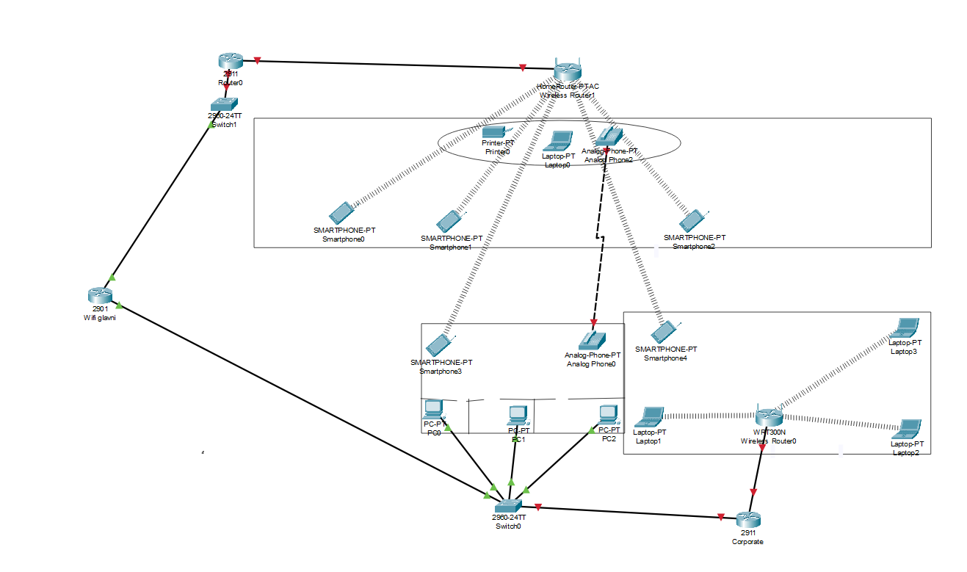
Room number 1 is a guest area with a reception and cash desk (with access to the service Wi-Fi), as well as a telephone (reception - office), guests do not have access to the service Wi-Fi.
Room number 2 is the main office space, also with access to public Wi-Fi and a telephone (office-reception)
Room number 3 is an office with the same functionality.

2.3 Setting up the main Wi-Fi router
1. Enter developer mode using En and go straight to the configurator.
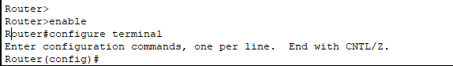
2. Create a VLAN
- Vlan 10
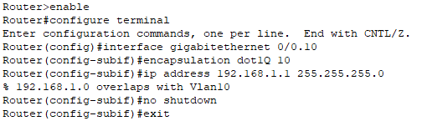
- Vlan 20
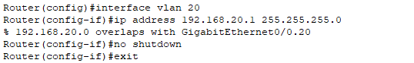
3. Setting up Switch 1
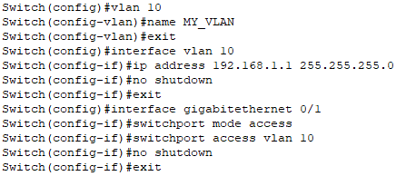

4. Setting up a switch for employees


- Set a password using Cisco's enable secret

5. Checking VLANs
- Vlan 20 on Wireless Router0
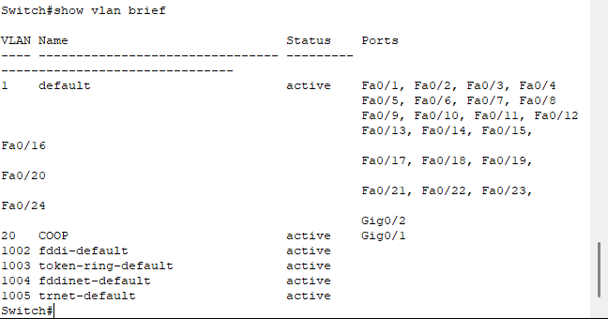

- Vlan 10 on Wireless Router1
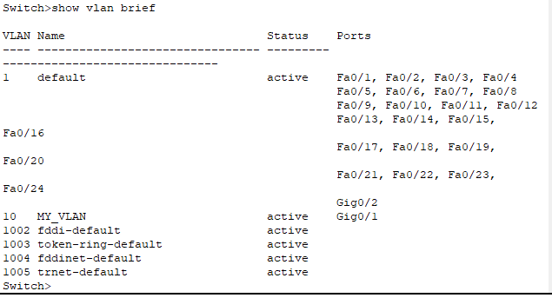

2.4 Setting up Laptops for Employees in COOP
The tool used in the laptopPT-LAPTOP-NM-1W module provides one 2.4GHz
So, we enable privileged mode and go to the configuration. We then create VLAN 10 with the name My_VLAN and VLAN 20 with the name COOP. Save the configuration.

To enable VLAN operation, we assign ports: for example, port 1 for VLAN 10 (servers), port 2 for VLAN 20 (users). If necessary, we configure IP addresses on the VLAN interfaces for routing between segments.

CONCLUSION
This project successfully achieved its primary goal: to develop and virtually implement a secure and efficient computer network for an organization integrating wired and wireless technologies.
To achieve this goal, a set of tasks was consistently solved:
An analysis of modern wireless network standards and technologies was conducted, which made it possible to justify the choice of current solutions (Wi-Fi 6) for the designed network.
The principles of network segmentation and security were studied, on the basis of which a VLAN-based architecture was selected and applied for logical separation of traffic (employees, guests, servers).
A comparative analysis of WLAN architectures was conducted, based on the results of which a centralized (controller) architecture was selected for the project as the most suitable for ensuring a unified security and management policy.
A detailed network infrastructure, including a router, switches, access points, servers, and workstations, was developed and implemented in the Cisco Packet Tracer simulation environment.
The main practical result of the project is a functioning virtual network model, which includes:
Logical segmentation into VLANs (SERVERS and USERS), providing traffic isolation and increased security.
Configured wireless networks using modern authentication methods (WPA2/WPA3).
Implemented basic routing between network segments.
Configured fault tolerance and management on switches (spanning-tree protocol, link aggregation).

The theoretical significance of the work lies in the systematization of knowledge on the evolution of Wi-Fi, the classification of computer networks, coverage planning methods, and modern approaches to ensuring security in wireless environments.

The project's practical value lies in the fact that the developed configuration can serve as a standard template for deploying secure small- and medium-sized corporate networks. All settings, including VLAN creation, port assignment, DHCP and routing configuration, were successfully implemented and tested in a simulator, confirming their functionality.

The direction for further development of the project could be:
Advanced Quality of Service (QoS) policy customization for prioritizing voice and video traffic.
Implementing a more complex security scheme, such as integration with a RADIUS server for 802.1X employee authentication.
Simulate the network under high load conditions and conduct fault tolerance tests to more accurately assess performance.

BIBLIOGRAPHY
- Olifer, V. G. Computer networks. Principles, technologies, protocols / V. G. Olifer, N. A. Olifer. - 5th ed. - St. Petersburg: Piter, 2019. - 992 p.
- Tanenbaum, E. Computer networks / E. Tanenbaum, D. Weatherall. - 5th ed. - St. Petersburg: Piter, 2019. - 960 p.
- Switching, Routing, and Wireless Essentials Companion Guide (CCNAv7) / Cisco Networking Academy. – Cisco Press, 2020.
[Electronic resource]. – URL: https://vk.com/wall-80984752_22233
- CCNP and CCIE Enterprise Core ENCOR 350-401 Official Cert Guide / [B. Odom and others]. – Cisco Press, 2020. [Electronic resource]. – URL: https://vk.com/wall-43608611_1386
- Cisco LAN Switching Configuration Handbook. – 2nd ed. – Cisco Press, 2019.
- Vishnevsky, V. M. Theoretical foundations of designing computer networks / V. M. Vishnevsky. - M.: Tekhnosfera, 2003. [Electronic resource]. - URL: http://iitp.ru/upload/publications/442/%20%20().pdf
- Stack, T. Wireless Networks. The First Step / T. Stack; trans. from English. – Moscow: Williams, 2019. – 192 p.
- Official documentation of Cisco Systems. – [Electronic resource]. – URL: https://www.cisco.com/.
- Cisco Packet Tracer User Guide [Electronic resource]. – URL: https://www.netacad.com/.

